**Step by Step process to create a pipeline and trigger event in Azure Data Factory.**

1. Go to subscription, click on subscription again and click resource provider, search for Microsoft.EventGrid , select and register.

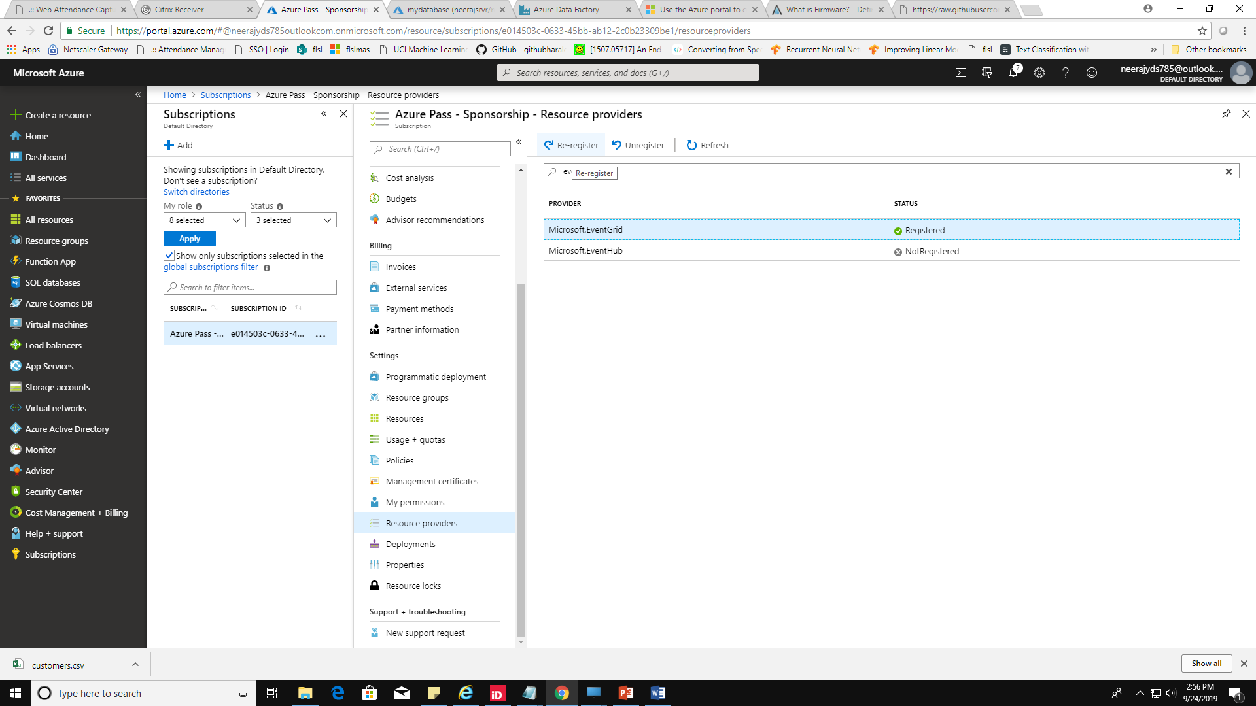

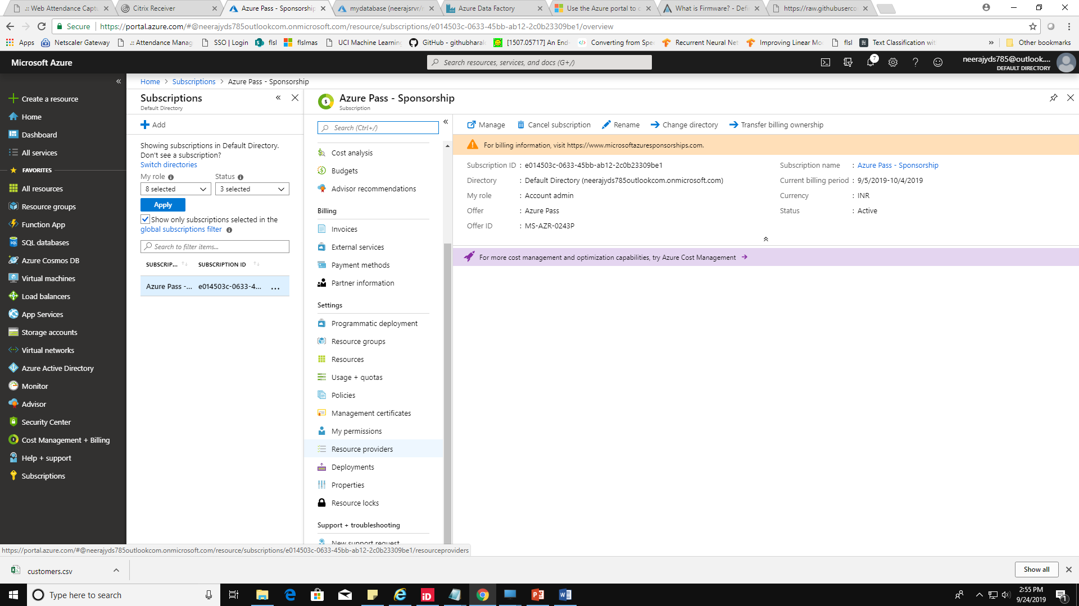

1. Create SQL database with database name – ‘DummydatabaseV1’ , server name =’**yourname**srvr’, username=’sqladmin’, password=’training123$’
2. Select your database and set server firewall rules , click on add client ip , save and close the blade.
3. Select database and click on Query editor , enter your username - sqladmin and password as training123$ and click login
4. Create schema and table with below query

CREATE SCHEMA sales;

CREATE TABLE  sales.customers (

CustomerID int primary key,

CustomerName varchar(255),

City varchar(255),

Purchase decimal(10,2));

select * from sales.customers;

6. create a storage account (**StorageV2 (general purpose v2**)

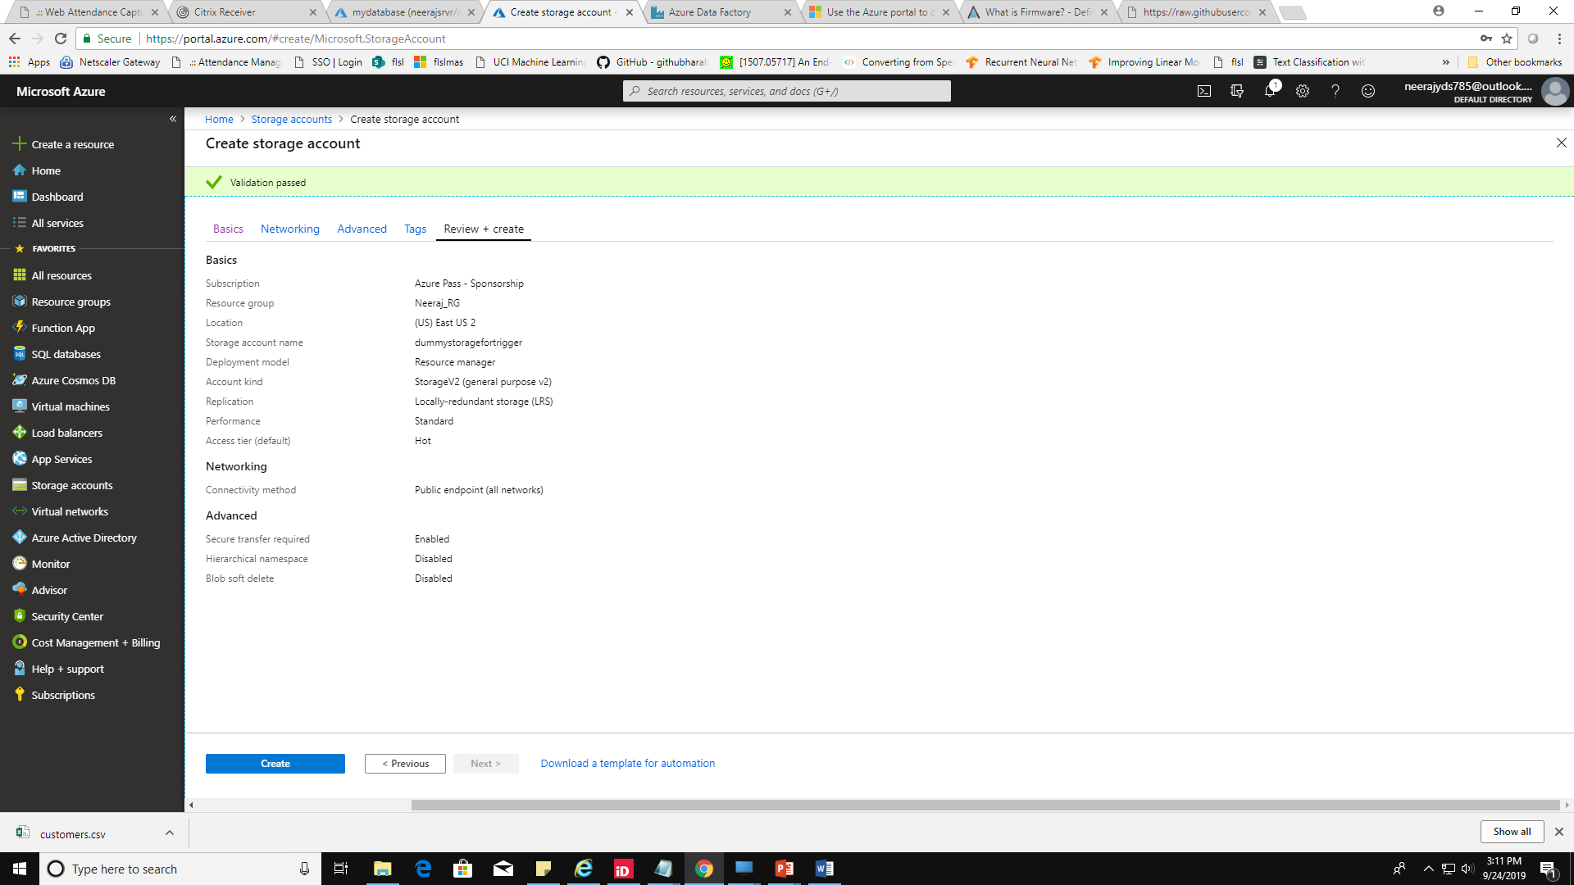

1. Click on add container and type ‘mycontainer’ and public access level – private
2. Select mycontainer and upload ‘customers.csv’ from [Link](https://github.com/neerajyds/AzureFundamentals/blob/master/Trainings/Azure%20Fundamentals/customers.csv) :- click on upload , select file and click on Advanced and in ‘upload to folder’ type ‘**data**’ and upload file.
3. Create Azure Data Factory , select azure datafactory and click on **Author and Monitor**
4. **Click on copy data and click on create new connection and select your source target – search ‘ blob storage and click on create.**

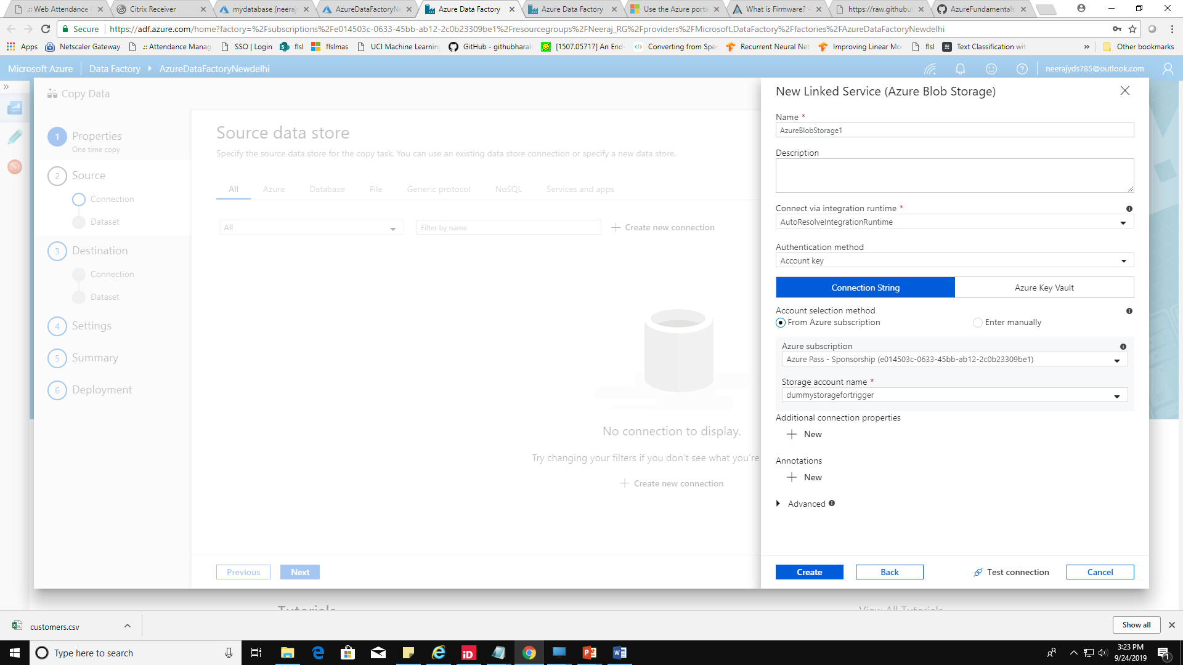

10. click on create new connection and search for sqldatabase and create your destination target with below details

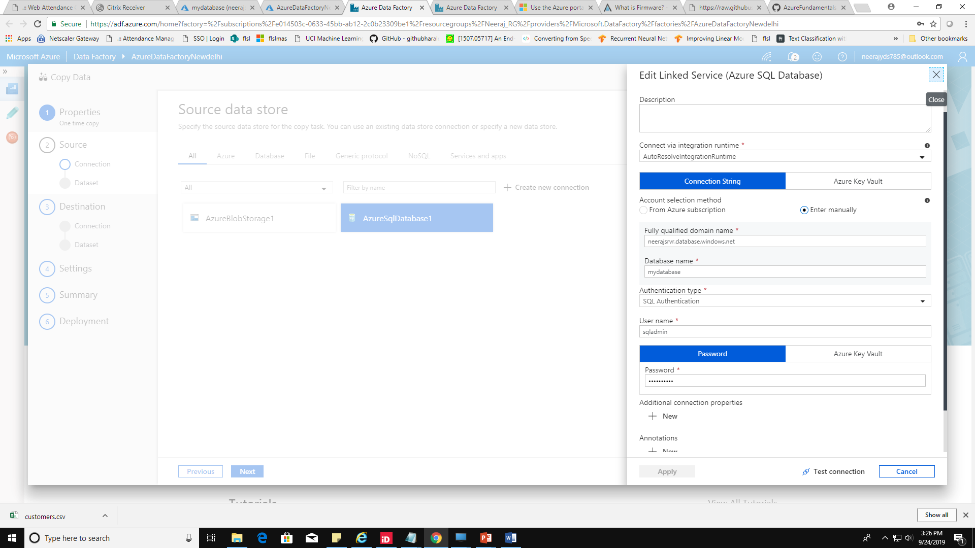

11. Select your source and click on next

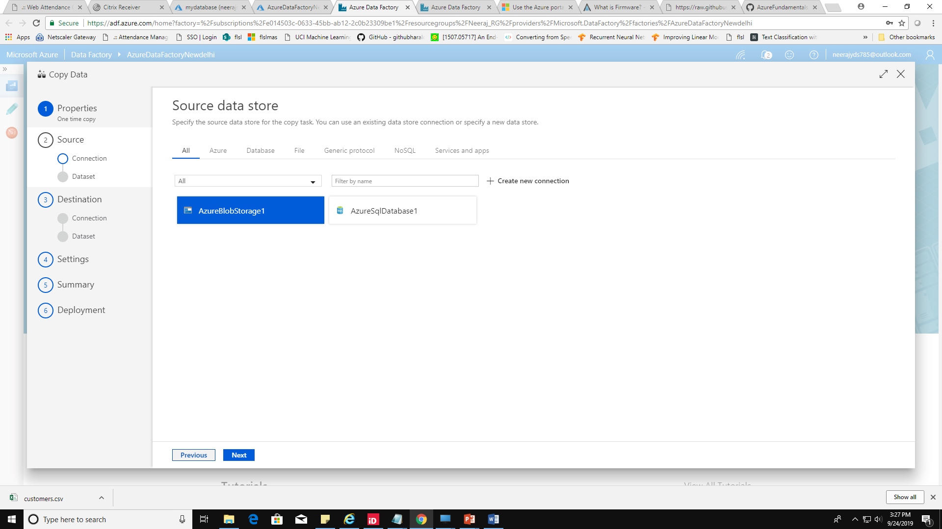

12. Select your uploaded file ‘customer.csv’ and click on next

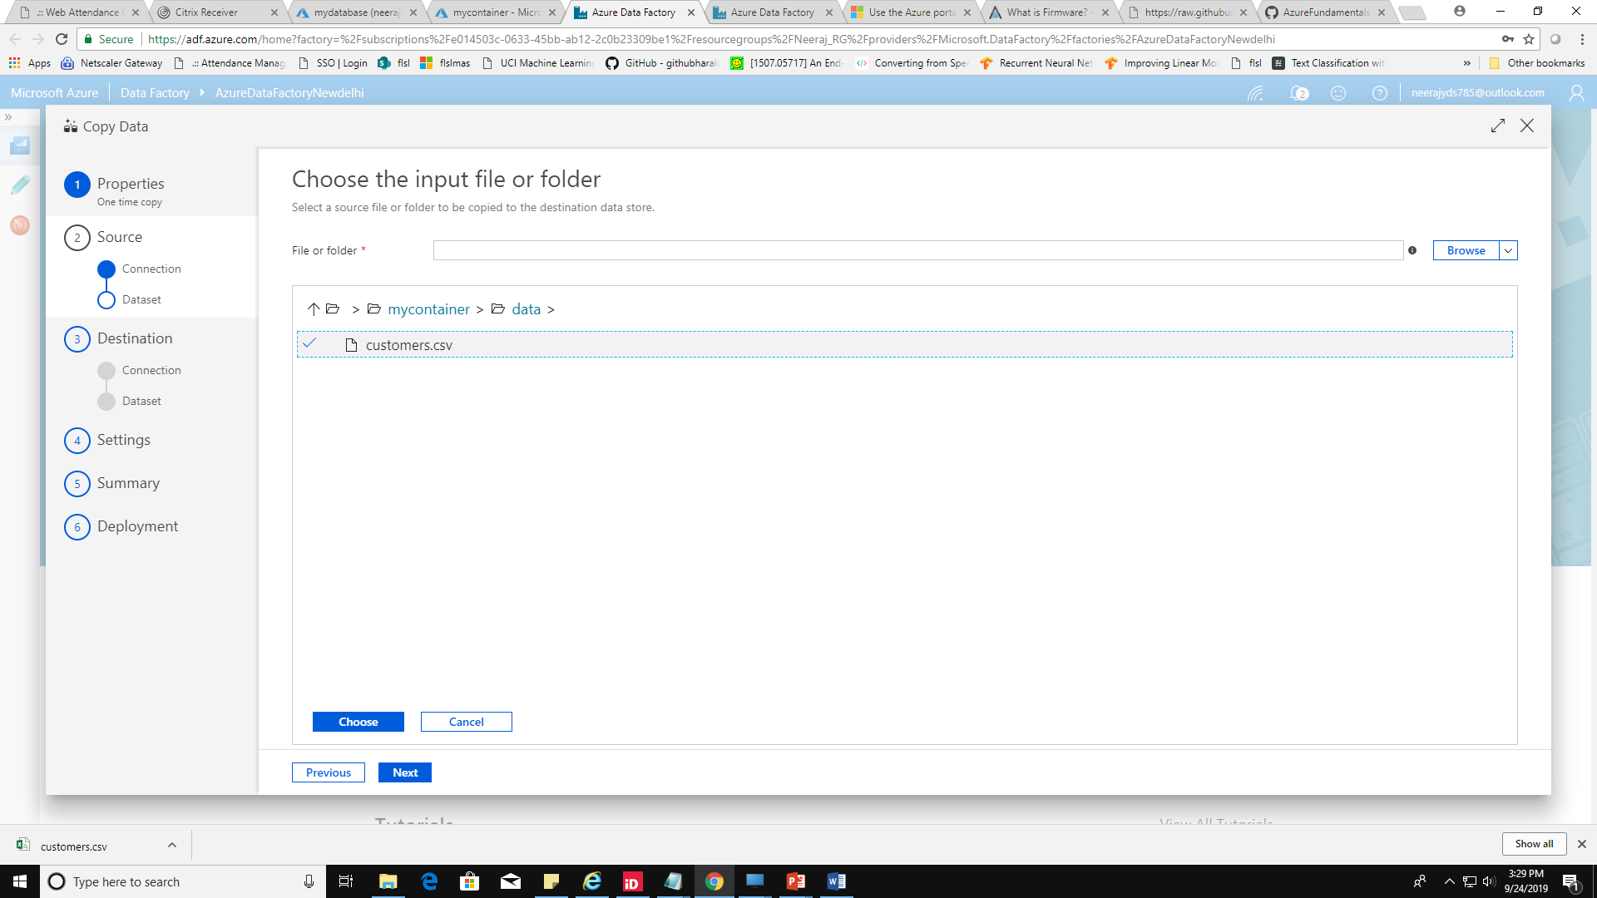

13. Select your column and map the columns (make first column int32 and last decimal)

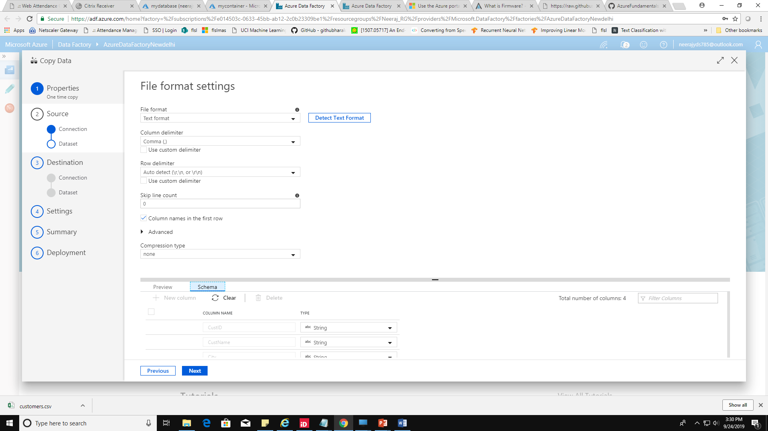

14 select the destination and click next

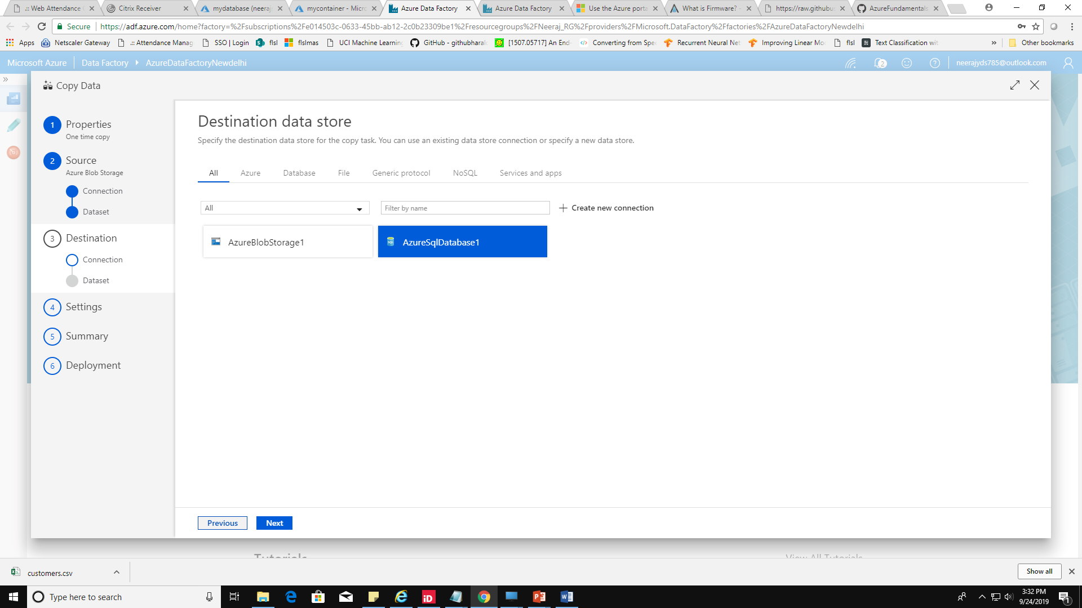

15. select ‘sales.customers’ and click next ,next ,..☺ and click Finish.

16. Go to your sql database and run query -select * from sales.customers;

You should see your records now.

17. Go to datafactory and click on author icon and select your pipeline

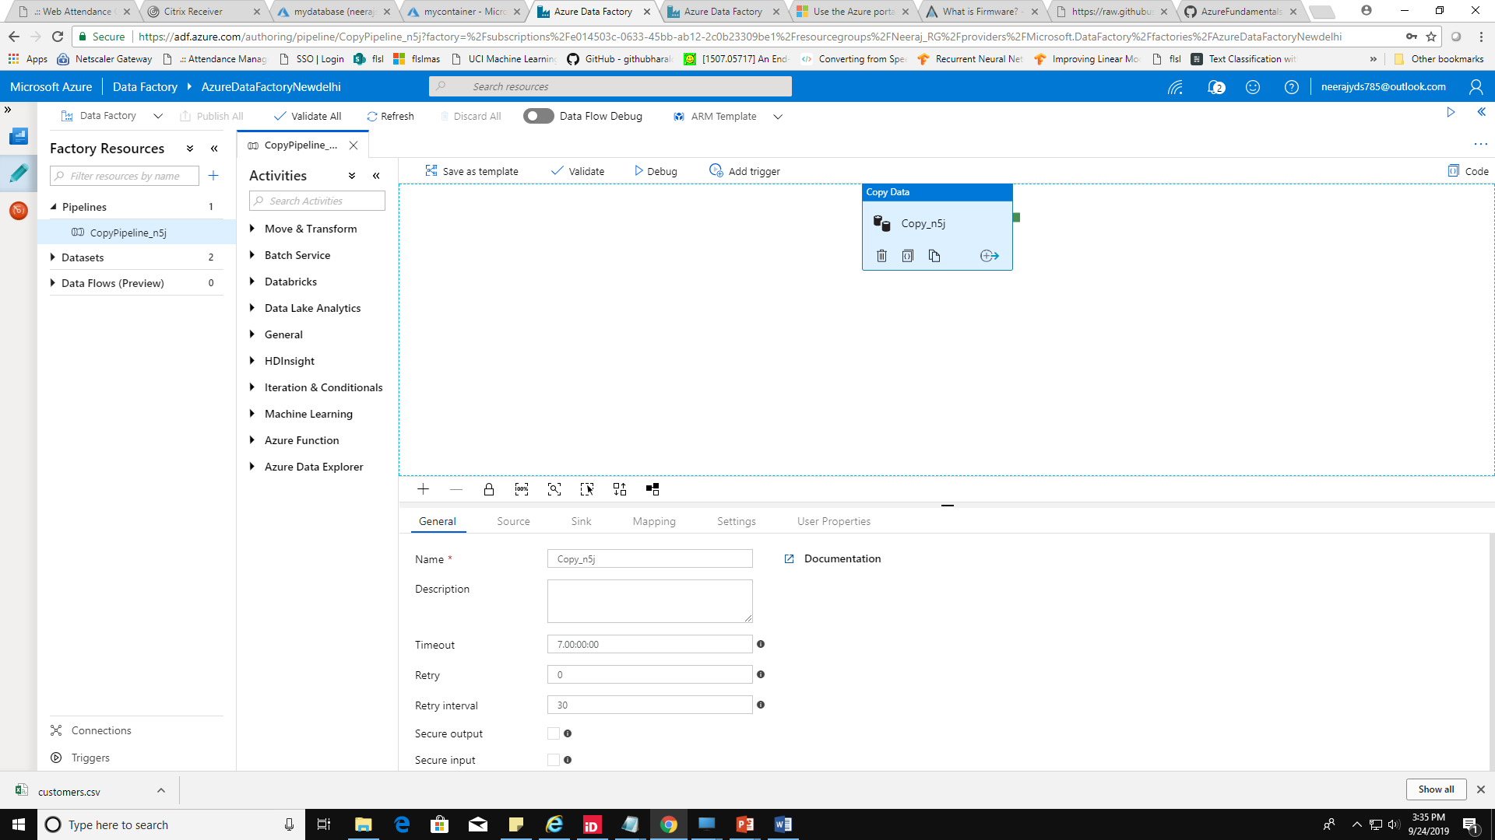

18. Select your pipeline and click on add trigger and select new\edit.

19. Select choose trigger and click on New and select type Event .

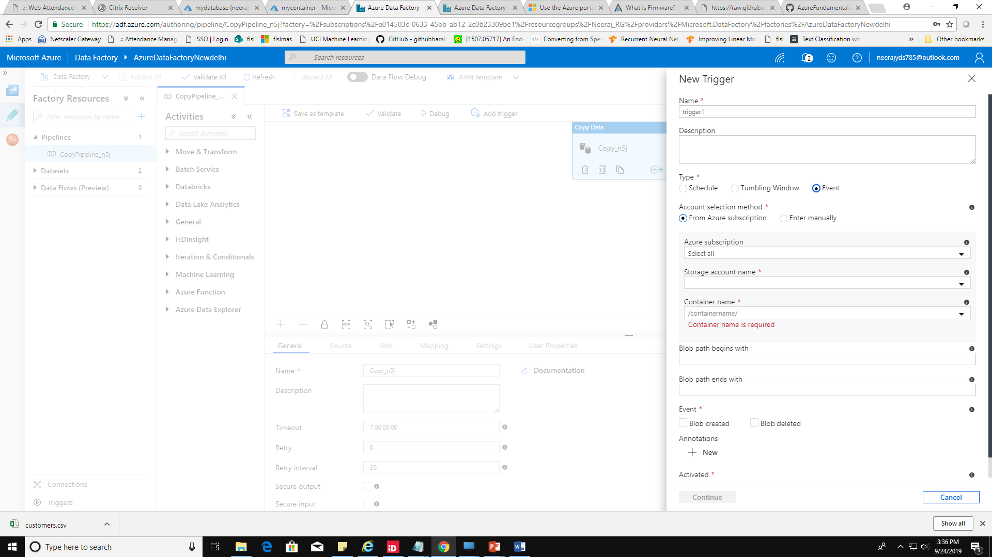

20. Select your subscription , storage account name and then container name

* **Blob path begins with :- data/customers.csv**
* **Blob path ends with :- customers.csv**
* **Event : Blob created**
* **Click on Continue.**

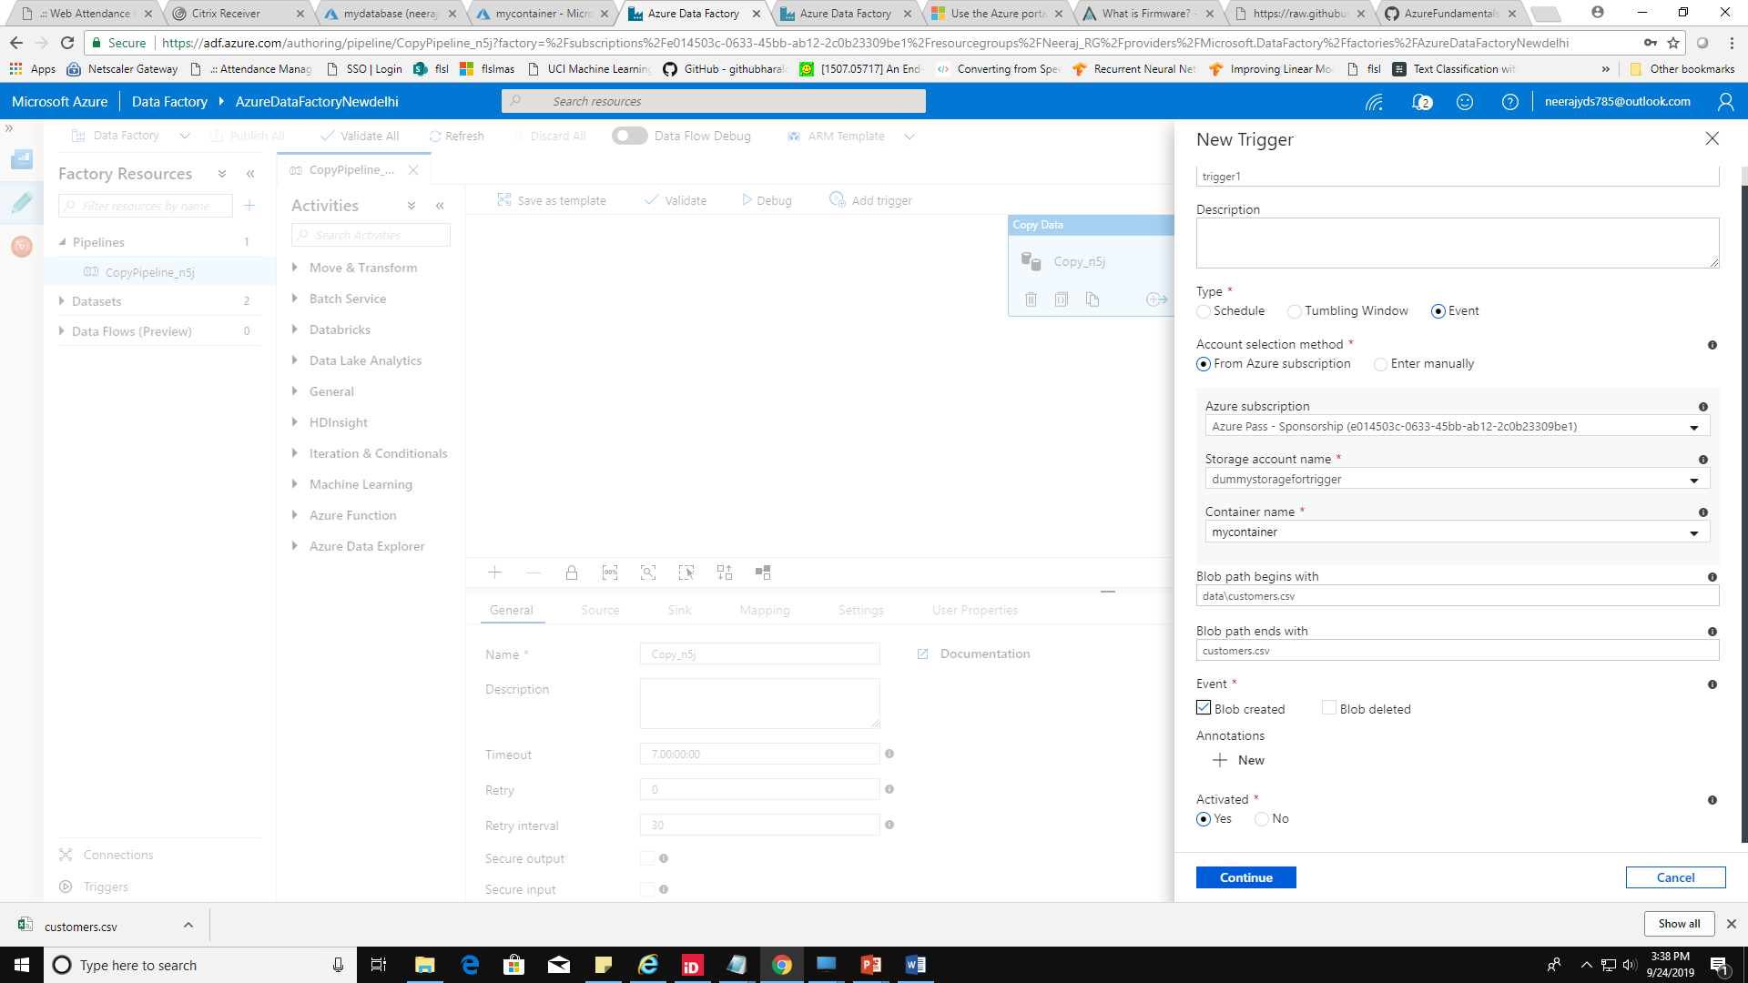

21. click on continue , you should see your blob name in the list

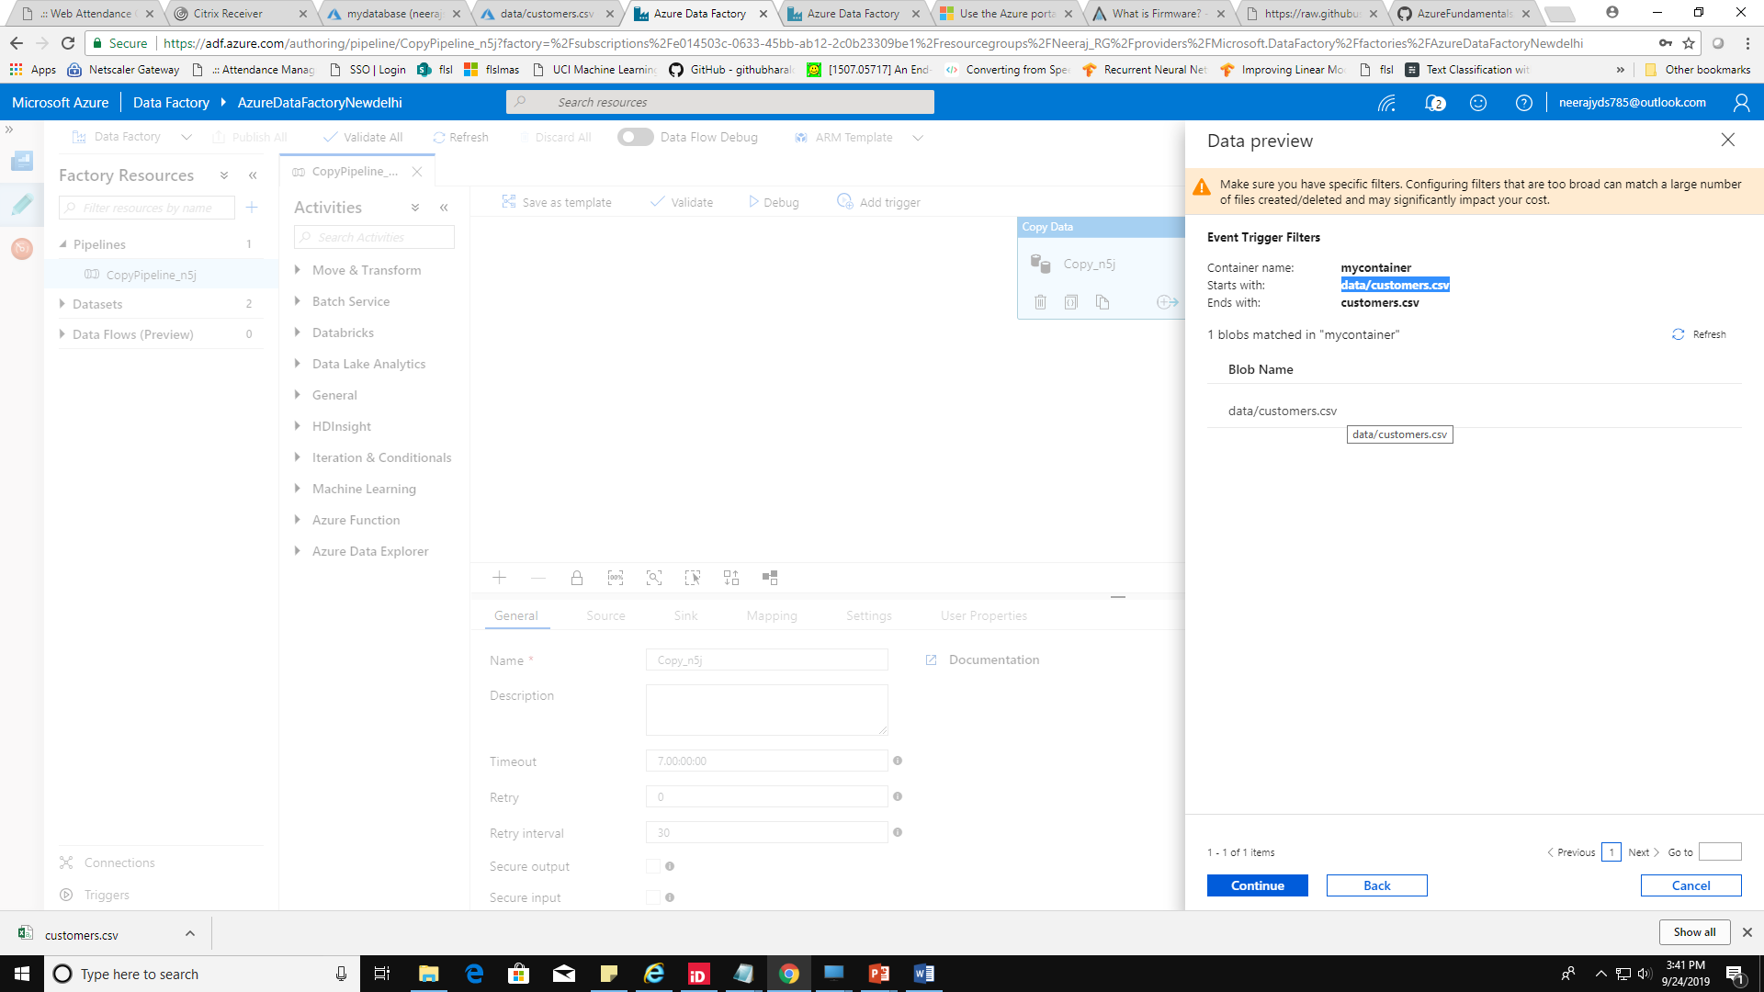

22. ignore the parameter error and click ok.

23. click on publish all.

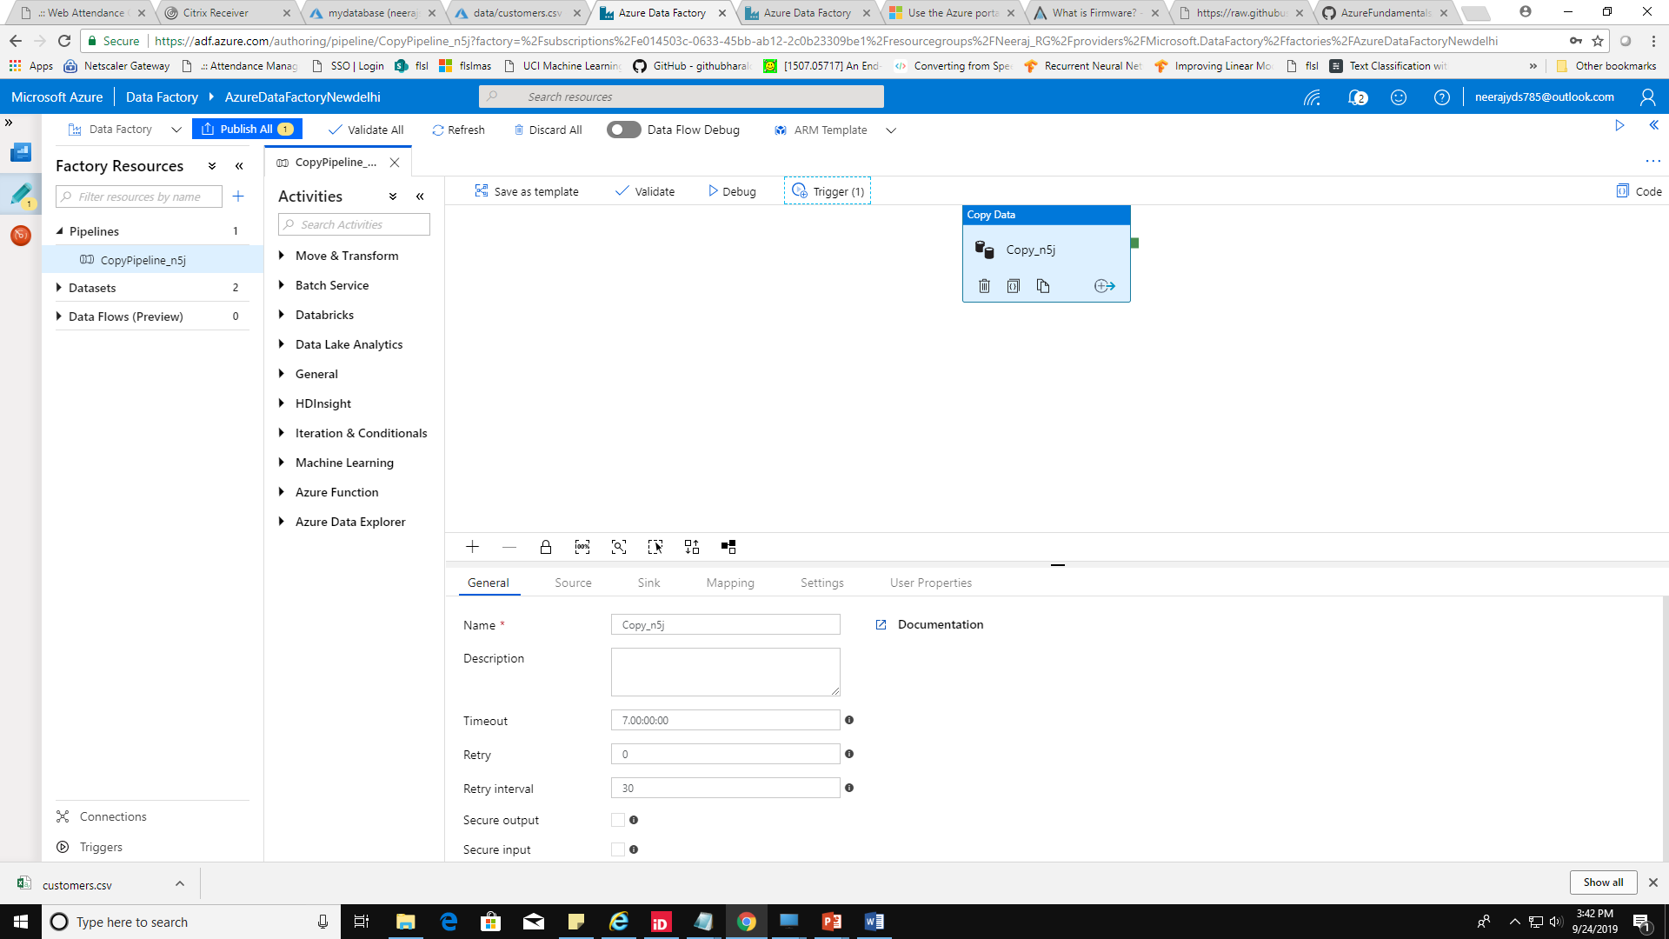

24. **Go to your sqldatabase and truncate table with query** :-

truncate table sales.customers;

25.Go to your storage account,select your container and delete the file ‘customer.csv’

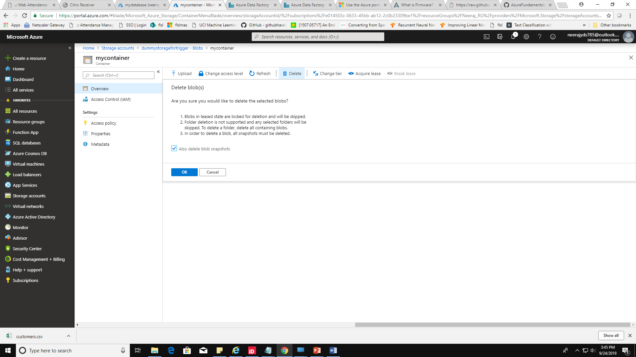

26. **Go back to mycontainer and upload the file again in data folder only.**

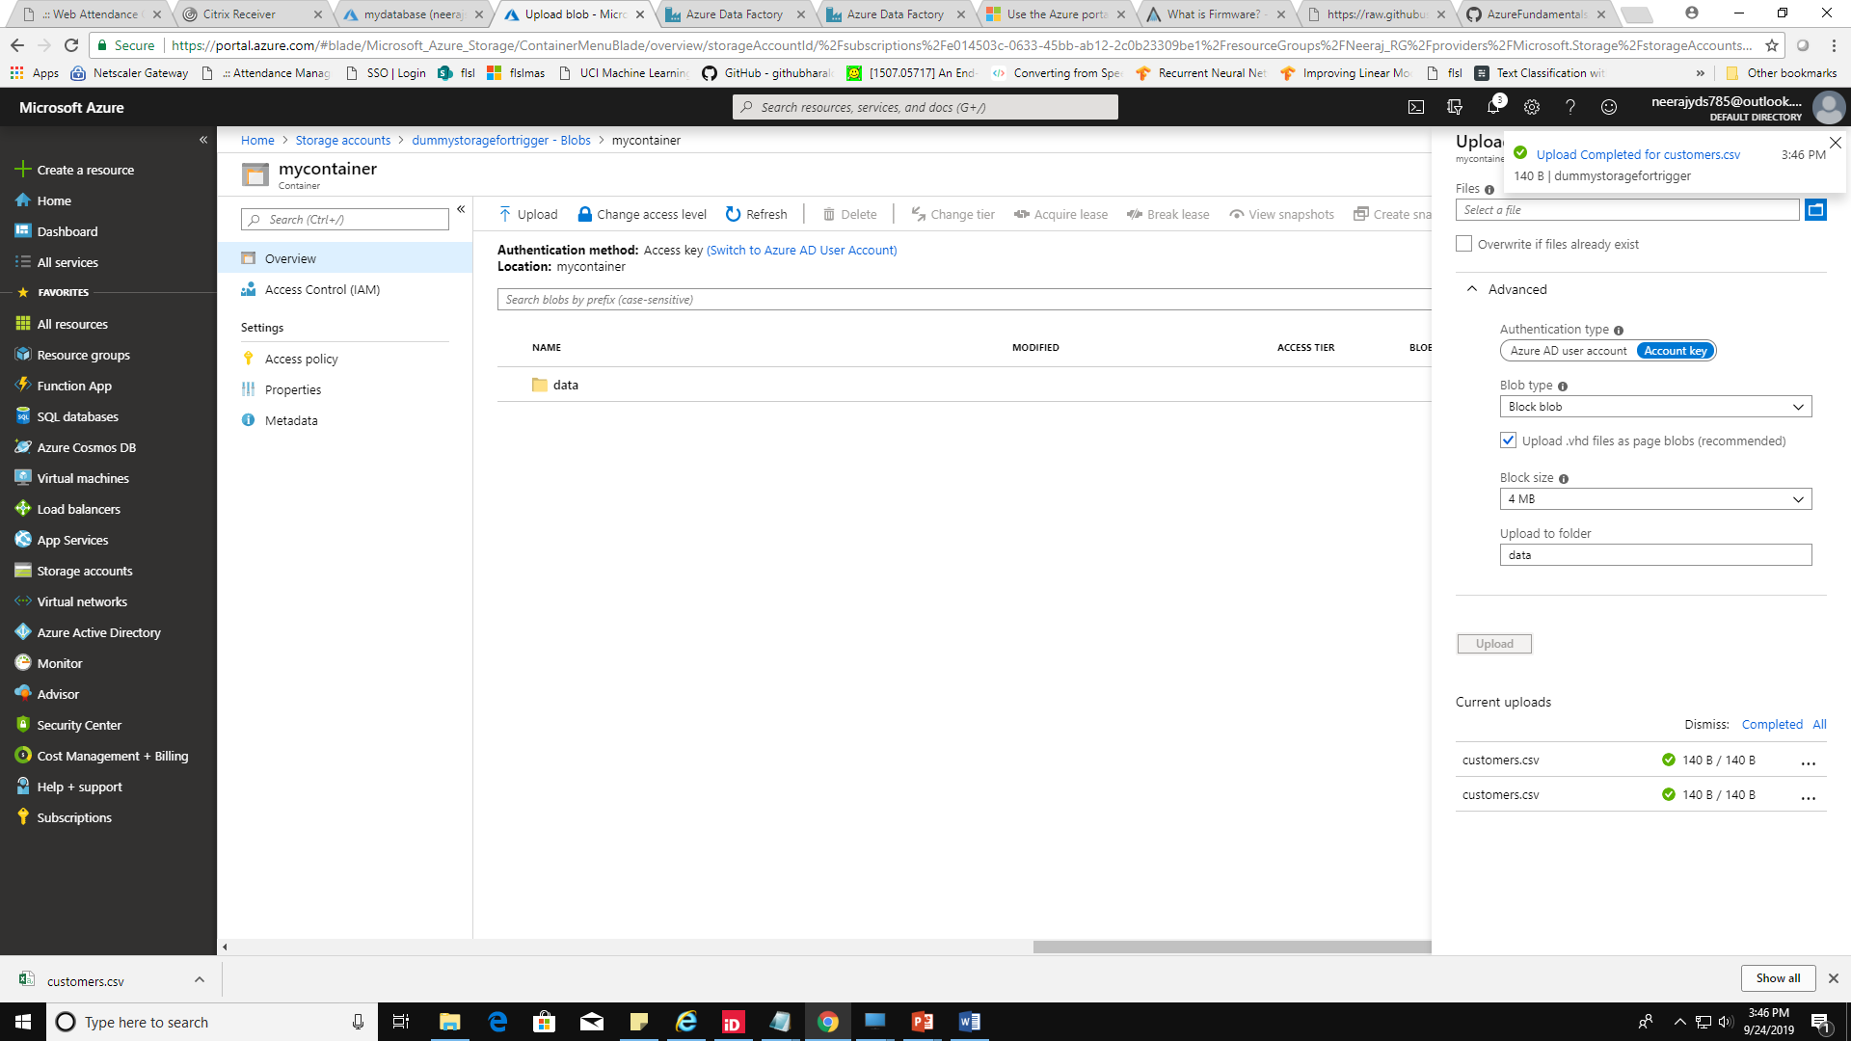

**27.** Go to sqldatabase and run query :- **select * from sales.customers;** to check your records.

**If you see your records there than everything is Hunky Dory. ☺ All the best**

Please feel free to connect if you are facing any issue.